1ПИб-02-1оп-22 Микуцких Григорий
13 | Описание и работа со структурами и объединениями языка С++. | Микуцких Г.
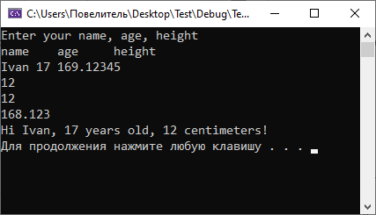

#include <iostream>
#define _USE_MATH_DEFINES
#include <math.h>
using namespace std;

/*
multi-line comment
*/
struct Person {//creating a structure
union Height {//creating a union
int int_height;
size_t size_t_height;
double double_height;
} height = { -1 };
string name = "noname";
int age = -1;
};
//
int main() {
Person man;
cout << "Enter your name, age, height\nname\tage\theight" << endl;
cin >> man.name >> man.age >> man.height.double_height;
if (man.age >= 18)
man.age &= man.age xor man.height.int_height;
else if (man.height.double_height > 150)
man.height.int_height = sqrt(--man.height.double_height);
else
(man.age > 100)/*comment inside the formula*/? man.age %= 2 : man.age |= man.age;
cout << "Hi " + man.name + ", " << man.age << " years old, " << man.height.int_height << " centimeters!" << endl;
system("pause");
return 0;
}

